

PRESS RELEASE
Harden renews its commitment to pediatric oncology research in support of the Charles-Bruneau Foundation
Montreal (Quebec), September 29, 2026 – Harden, a leading real estate development and investment company, has renewed its commitment to the Charles-Bruneau Foundation by sponsoring the Charles-Bruneau Cup and rallying its employees and teams for the sixth consecutive year. The 2026 edition of the friendly ball hockey tournament, held on September 26 at the IGA Stadium in Montréal, raised $1.365 million for the Foundation.
Through its involvement and commitment, Harden helps support the Charles-Bruneau Foundation’s mission to improve the chances of a cure for children with cancer by funding pediatric hematology-oncology research.
“For us, the Charles-Bruneau Cup is much more than just a sporting event. It is an opportunity to come together in support of children with cancer and their families, while honouring the dedication of the volunteers and the entire Charles-Bruneau Foundation team, who work tirelessly to advance this cause,” stated Tyler Harden, Harden’s Co-Chief Executive Officer and Treasurer for the Charles-Bruneau Foundation. We are proud to be part of this collective effort and grateful for the commitment of our employees and teams, whose support helps advance research and improve the chances of a cure for children living with cancer.”
The Charles-Bruneau Cup is a fun, friendly ball hockey tournament held in support of the Foundation. Launched in 2021, the tournament has grown into one of the Foundation’s signature events, held in both Montréal and Québec City. The Cup pays tribute to Charles Bruneau, a hockey enthusiast whose dream of curing childhood cancer inspired the Foundation’s mission.
According to the Foundation, the Charles-Bruneau Cup has raised nearly $5 million since its inception. The proceeds most notably help fund pediatric hematology-oncology research and innovative platforms while also supporting different initiatives aimed at improving the quality of life of children with cancer and their families.
Harden would like to thank its team, participants, donors and partners for their contribution to the initiative’s success as well as the Charles-Bruneau Foundation for its ongoing commitment to supporting children with cancer and their families.
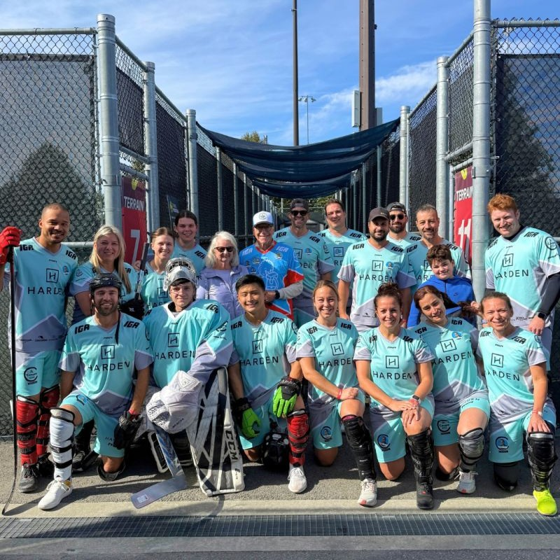
Pierre Bruneau and Ginette St-Cyr accompanied by members of the Harden team at the Charles-Bruneau Cup on September 26, 2026 at the IGA Stadium in Montréal. The Harden Group renewed its support for the event this year, helping fund pediatric cancer research through the Charles-Bruneau Foundation.
About Harden
Established in 1985, Harden is a second generation, family-owned real estate company whose primary focus is owning and operating commercial, residential, and industrial properties in many communities throughout the provinces of Quebec and Ontario. Vertically integrated, Harden specializes in all facets of the real estate development process, including, development, construction, leasing, and asset management.
To learn more about Harden, please visit www.harden.ca
-30-
For more information:
Dalia Esposito
Torchia Communications
514 654-2635 / dalia@torchiacom.com

