


Faubourg Contrecœur retail lineup now complete as Harden and Crombie sign Dollarama and McDonald's
Commercial hub moves into full construction phase with opening planned for summer 2026
Montreal, QC, July 6, 2026 – Harden and Crombie are pleased to announce Dollarama and McDonald’s as two new tenants of Faubourg Contrecœur, their newest commercial development in Mercier–Hochelaga-Maisonneuve, Quebec. The commercial development has reached a major milestone with the signing of these clients, bringing the project to 100 per cent occupancy.
Developed in partnership with Harden and Crombie, Faubourg Contrecœur is now firmly in the development phase, with construction advancing steadily across the site. With all commercial spaces now leased, the project will eventually bring long-awaited services to the neighbourhood.
Dollarama will occupy approximately 9,726 square feet and McDonald’s approximately 3,046-square-feet. Construction is underway for both with a targeted opening end of summer and early fall. A cornerstone tenant, the new IGA grocery store is scheduled to open on August 13, 2026. The store will span approximately 40,020 square feet and serve as a cornerstone of the commercial centre.
“We are proud to bring this project to life in partnership with Crombie and deliver a quality, necessity-based retail offering that supports the everyday needs and affordability of local residents while creating long-term value for the community”, says Tyler Harden, Co-CEO of Harden. “We look forward to welcoming customers this summer.”
Once completed, Faubourg Contrecœur will provide residents a well-rounded retail environment, supporting the continued growth of the surrounding neighbourhood. The project is expected to become a central shopping hub for daily necessities, while responding to a long-standing demand from many local residents for new businesses and commercial development in the area. Faubourg Contrecœur is located at 3553 rue de Contrecœur, Montreal, QC, the intersection of rue Sherbrooke Est and rue de Contrecœur.
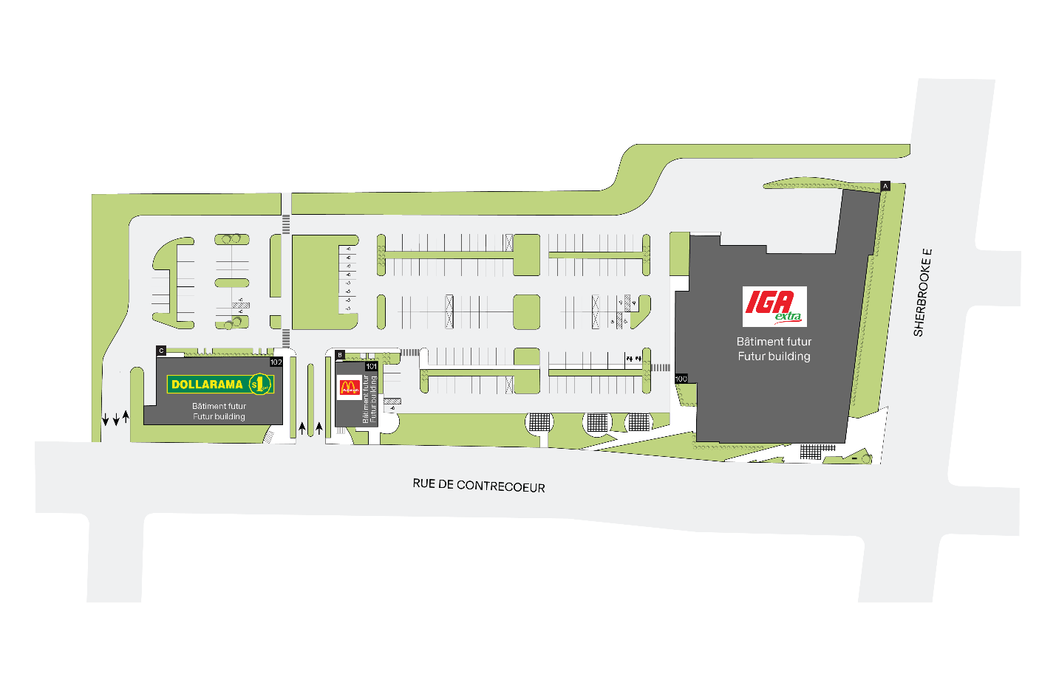 Site plan of Faubourg Contrecœur, the new commercial development by Harden and Crombie REIT in Montréal’s Mercier–Hochelaga-Maisonneuve borough. With the addition of Dollarama and McDonald's alongside anchor tenant IGA, the retail centre has now reached full occupancy ahead of its planned summer 2026 opening.
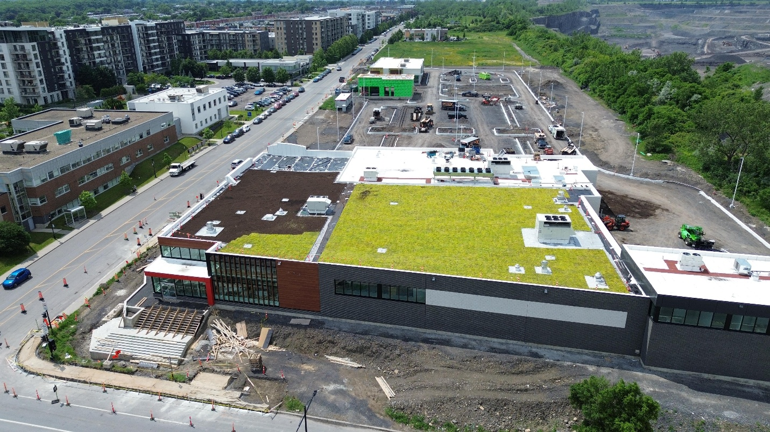Aerial view of the new commercial development Faubourg Contrecœur in Montréal’s Mercier–Hochelaga-Maisonneuve borough. With the addition of Dollarama and McDonald's alongside anchor tenant IGA, the retail centre has now reached full occupancy ahead of its planned summer 2026 opening.
About Harden
Established in 1985, Harden is a second generation, family-owned real estate company whose primary focus is owning, developing and operating commercial, residential, and industrial properties in many communities throughout the provinces of Quebec and Ontario. Vertically integrated, Harden specializes in all facets of the real estate development process, including development, construction, leasing, and asset management.
To learn more about Harden, please visit www.harden.ca
About Crombie
Crombie invests in real estate with a vision of enriching communities together by building spaces and value today that leave a positive impact on tomorrow. As one of the country's leading owners, operators, and developers of quality real estate assets, Crombie's portfolio primarily includes grocery-anchored retail, retail-related industrial, and mixed-use residential properties. As of June 30, 2025, our portfolio contained 306 properties comprising approximately 18.8 million square feet, inclusive of joint ventures at Crombie's share, and a significant pipeline of future development projects. Learn more at www.crombie.ca.
-30-
For further information:

Dalia Esposito
Torchia Communications
514-654-2635 / dalia@torchiacom.com

